The 2017 Montgomery Boys Basketball Golf Outing
“Where FAMILY Never Graduates”

AUCTION DONATION AGREEMENT
Name of Donor:
Address of Donor:

Telephone: (Home)
(Cell)
E-mail Address:

Donated Item:
(Please provide a description)

Value of Donation: $

Special Comments:

Please return auction agreement to Maria Levy (sixthmanclubb@gmail.com) by October 11th and be certain to retain a copy for your records. Please email us with any questions.
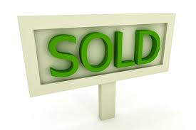
THANK YOU FOR YOUR DONATION and SUPPORT!

